1. **Include in** program.cs

**[STAThread]**

static void Main(string[] args) ....

1. **INSTALL Selenium**

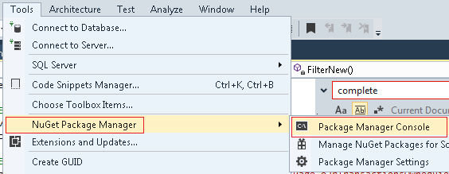

1. **PM> Install-Package Selenium.WebDriver**
2. **PM> Install-Package Selenium.WebDriver.ChromeDriver**

Install-Package Selenium.WebDriver.ChromeDriver -Version 94.0.4606.6100

Include

* System.Configuration
* UIAutoamtionClient

Reference / Add Reference /Assemblies

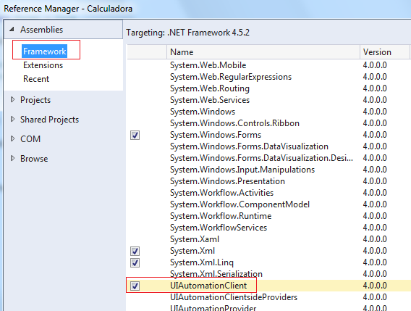

using System;

using System.Windows.Forms;

using OpenQA.Selenium;

using OpenQA.Selenium.Chrome;

using System.Configuration;

namespace Portico

{

public partial class Form1 : Form

{

ChromeDriverService service = null;

IWebDriver driver = null;

IWebElement element = null;

public Form1()

{

InitializeComponent();

}

private void Form1_Load(object sender, EventArgs e)

{

service = ChromeDriverService.CreateDefaultService();

//driver1 = new ChromeDriver();

driver = new ChromeDriver(service, new ChromeOptions(), TimeSpan.FromSeconds(600));

driver.Manage().Timeouts().ImplicitWait = TimeSpan.FromSeconds(30);

driver.Manage().Timeouts().PageLoad = TimeSpan.FromSeconds(600);

driver1.Navigate().GoToUrl("https://odc-portico.convergys.com");

driver1.FindElement(By.Id("input_1")).SendKeys("tdal6392@sa.convergys.com");

string Password = ConfigurationManager.AppSettings["Password"].ToString();

driver1.FindElement(By.Id("input_2")).SendKeys(Password);

driver1.FindElement(By.Id("input_4_1")).Click(); // checkbox

System.Environment.Exit(0);

}

}

}

Si Sale

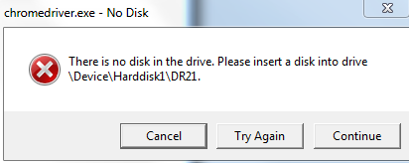

DAR Clean a Proyecto

ChromeDriverService service = ChromeDriverService.CreateDefaultService();

service.EnableVerboseLogging = true;

string LogPath=".";

service.LogPath = Path.Combine(LogPath, "chromedriver" + DateTime.Now.ToString("yyyyMMddhhmmss") + ".log");

IWebDriver driver = new ChromeDriver(service, new ChromeOptions(), TimeSpan.FromSeconds(300));

driver.Manage().Timeouts().ImplicitWait = TimeSpan.FromSeconds(30);

driver.Manage().Timeouts().PageLoad = TimeSpan.FromSeconds(300);

driver.Navigate().GoToUrl(FieldGlassUrl);

IWebElement element = null;

IWebElement splitWindowList = null;

ReadOnlyCollection<IWebElement> elements = null;

static ChromeDriverService service = null;

static IWebDriver driver = null;

static IWebElement element = null;

[STAThread]

static void Main(string[] args)

{

service = ChromeDriverService.CreateDefaultService();

//driver1 = new ChromeDriver();

driver = new ChromeDriver(service, new ChromeOptions(), TimeSpan.FromSeconds(600));

driver.Manage().Timeouts().ImplicitWait = TimeSpan.FromSeconds(30);

driver.Manage().Timeouts().PageLoad = TimeSpan.FromSeconds(600);

driver.Navigate().GoToUrl("https://console.karix.solutions/mreportui/");

string username = ConfigurationManager.AppSettings["username"].ToString();

string passwd = ConfigurationManager.AppSettings["passwd"].ToString();

driver.FindElement(By.CssSelector("input[type='text']")).SendKeys(username);

driver.FindElement(By.CssSelector("input[type='password']")).SendKeys(passwd);

System.Threading.Thread.Sleep(1000);

InputSimulator sim = new InputSimulator();

sim.Keyboard.KeyPress(VirtualKeyCode.TAB);

System.Threading.Thread.Sleep(2000);

sim.Keyboard.KeyPress(VirtualKeyCode.RETURN);

driver.FindElement(By.ClassName("btn-success")).SendKeys(OpenQA.Selenium.Keys.Enter);